QUARRY LAKE CLUBHOUSE – AUDIO-VIDEO SYSTEM USER GUIDE
Contents/Quick Links:
Control Panel Home Page
Change Room to Control
Watch
Cable TV
Blu-Ray DVD
Listen
Turn System Off
The Clubhouse Audio-Video system can:
- Play Television (Comcast Cable) in one or both rooms
- Play a DVD in one or both rooms
- Play Television in one room and a DVD in the other room
- Play music in one or both rooms

The system is controlled by a wall-mounted control panel near the thermostat
in each room. Each control panel can control the system in both rooms.

THE CONTROL SYSTEM TURNS EQUIPMENT ON AND OFF AND SELECTS AND CONFIGURES THE CORRECT INPUTS. DO NOT TURN THE EQUIPMENT ON/OFF YOURSELF OR PLUG/UNPLUG ANY CABLES, with the exception of connecting an HDMI or VGA to the appropriate wall jack.

Please report any issues IMMEDIATELY to WPM Real Estate Management, 443-796-7400 or greenspringquarry@wpmllc.com .

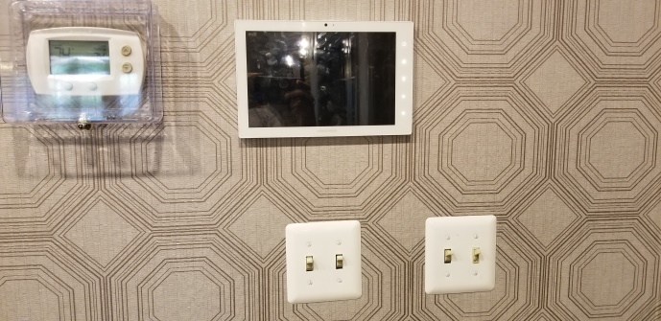 |  | 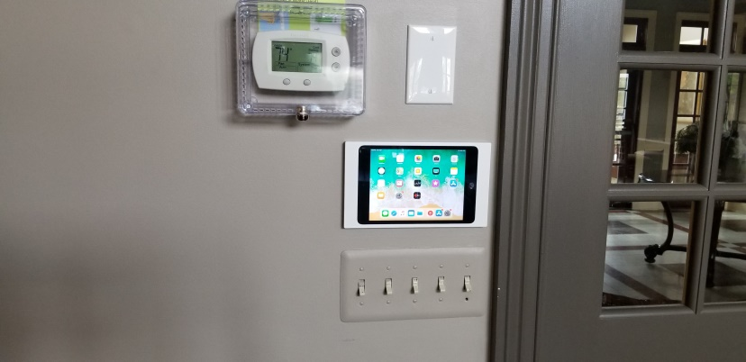
Card Room (Kitchen Room) Control Panel |  | Great Room Control Panel
To Start: |  | To Start:
- Tap the Screen to activate the Control Panel |  | - Press the iPad start button to activate the iPad screen  - If the blue application screen does not appear and the iPad icons apper, find the CRESTRON app and start it.  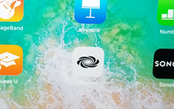
Control Panel Home Page  - Room Indicator (upper left)  - Indicates which room you are controlling  - Press to change rooms  - Off button (upper right)  - Press to turn room or rooms off  - Watch or Listen buttons  - Press to watch or listen | 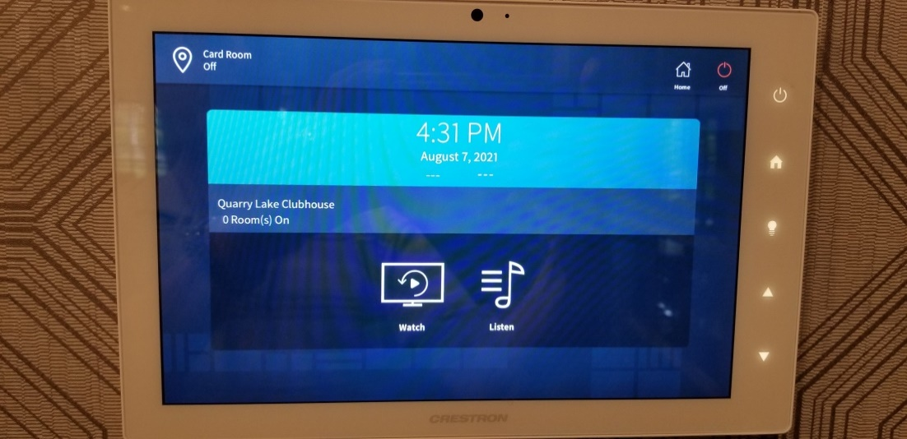
Pressing the Room button 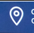 takes you to the Select a Room page.  Press Card Room to select the Card Room / Kitchen  Press Great Room to select the Great Room | 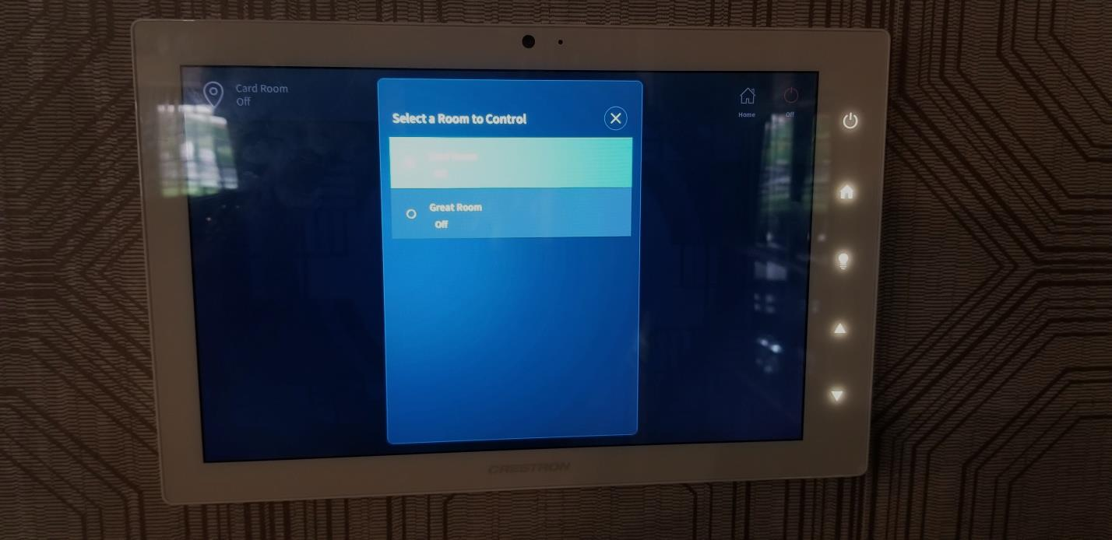
  Pressing the Watch button  takes you to the page to  select what to watch.  - Cable TV: Comcast is shown on the TV in the room you are controlling.  - Blu-ray: The Blu-ray DVD player is shown on the TV in the room you are controlling  - Wall Plate HDMI: A device you connect to the HDMI jack in the wall plate near the TV is shown on the TV.  - Wall Plate VGA (where available): A device you connect to the HDMI jack in the wall plate near the TV is shown on the TV. | 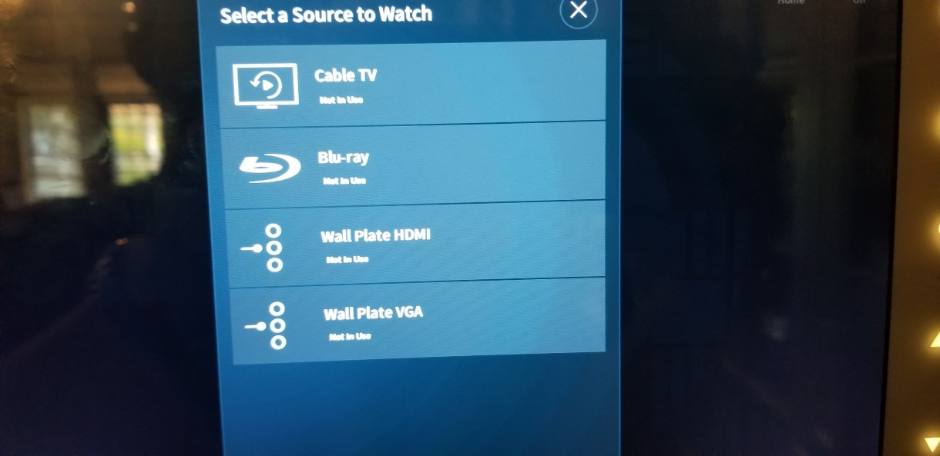  Card Room VGA and HDMI Great Room HDMI  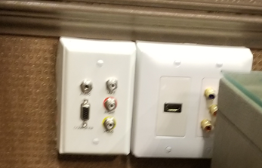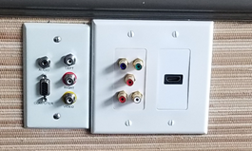
CABLE TV  The TV turns on and the Cable TV Control panel is shown.  The Clubhouse has Comcast Cable TV. Note that not all premium channels are available.  Volume control for the room you are controlling is at the bottom of the screen.  (Vol down, Mute, Vol up).  The Home button (upper right) will take you back to the Home screen. | 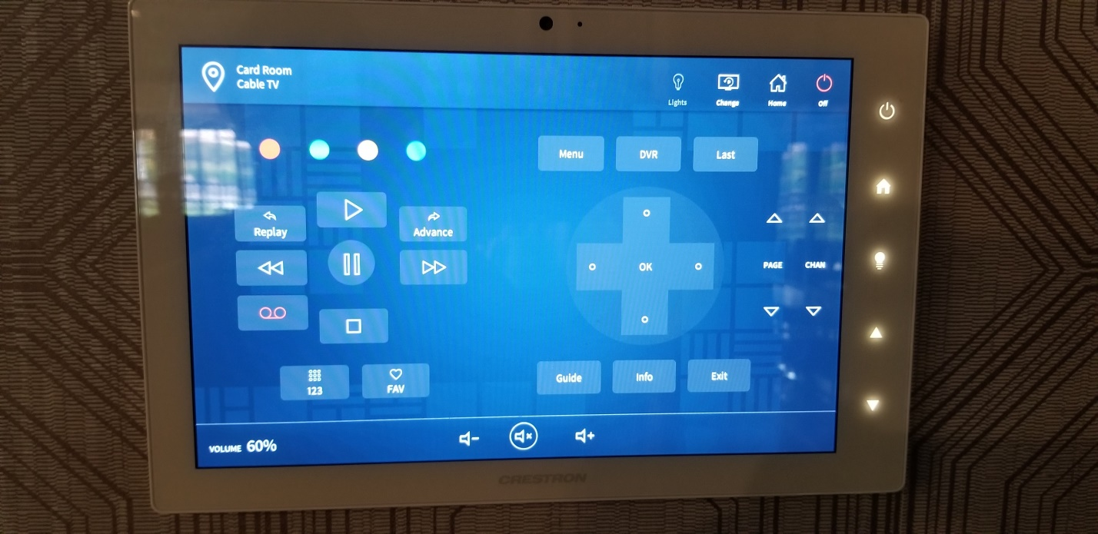
BLU-RAY DVD  The TV turns on and the Blu-Ray DVD Control panel is shown.  The DVD Player is located in the upper cabinet in the kitchen (see pictures below).  Volume control for the room you are controlling is at the bottom of the screen.  (Vol down, Mute, Vol up).  The Home button (upper right) will take you back to the Home screen. | 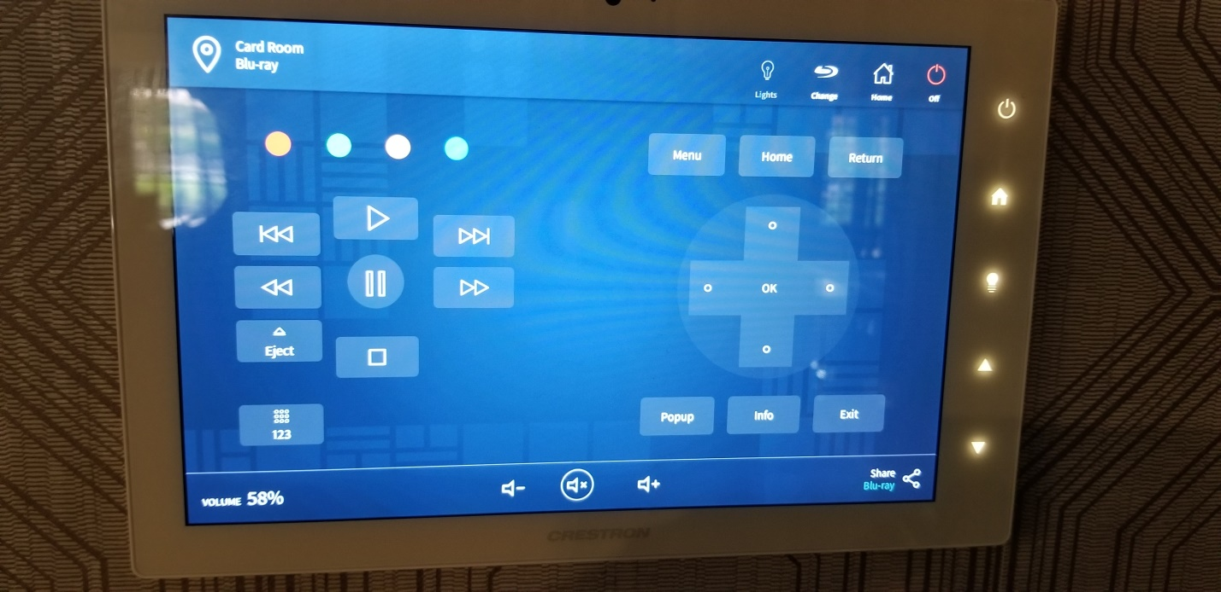
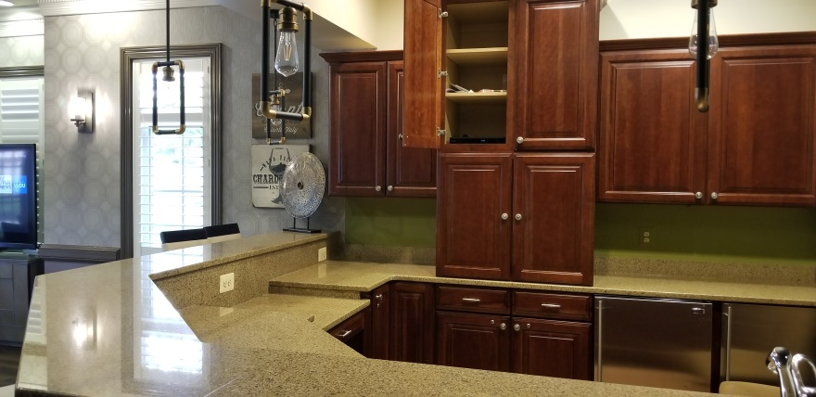 | 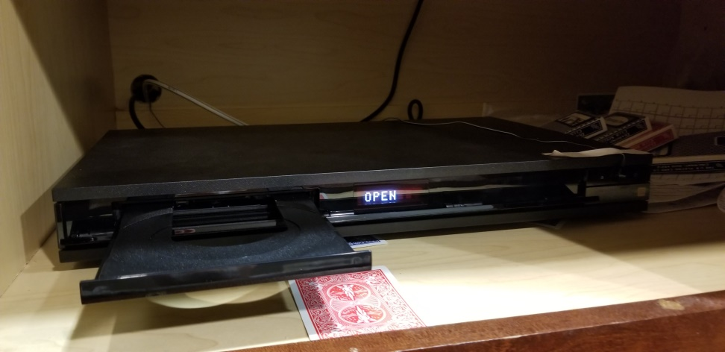
  Pressing the LISTEN button  takes you to the page to  select what listen to.  - SONOS: Service with a number of music channels pre-programmed | 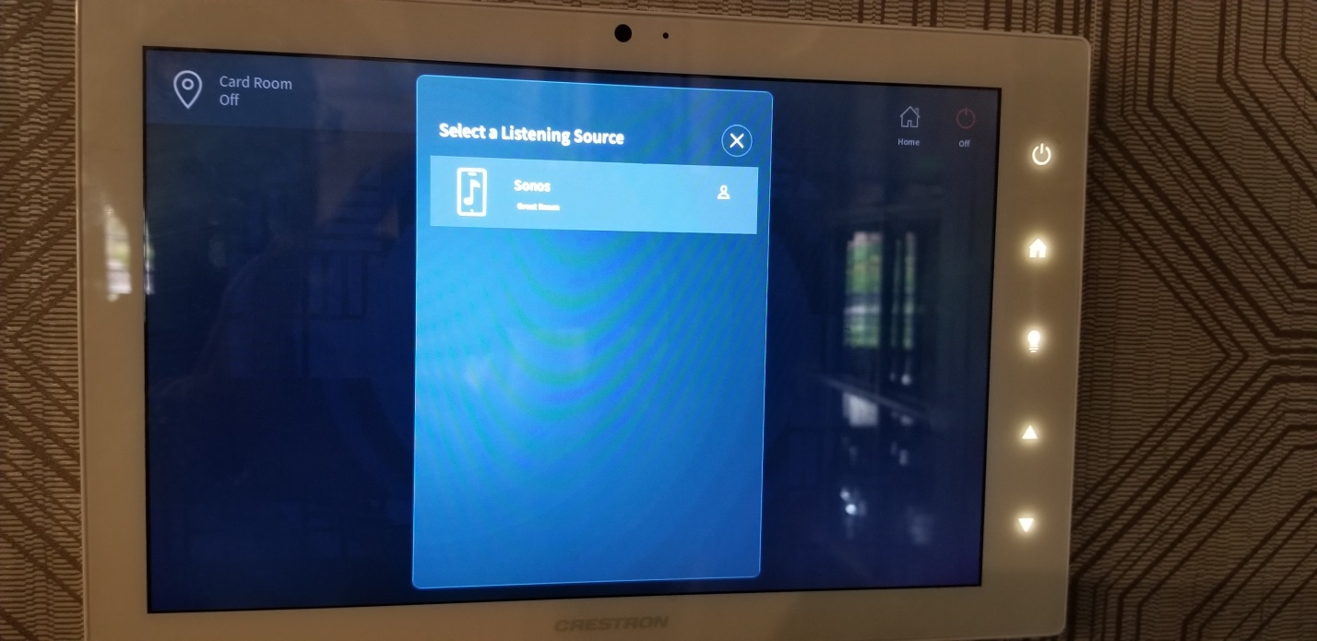
SONOS Music  Scroll down the list of Favorites on the right of the screen and select a kind of music you would like to hear.  Volume control for the room you are controlling is at the bottom of the screen.  (Vol down, Mute, Vol up).  The Home button (upper right) will take you back to the Home screen.  NOTE: If you have a device that can “cast” to SONOS, first start SONOS in the room(s) of your choice, then click the “cast” icon on your device and select SONOS. Your device’s audio will play on the room speakers. | 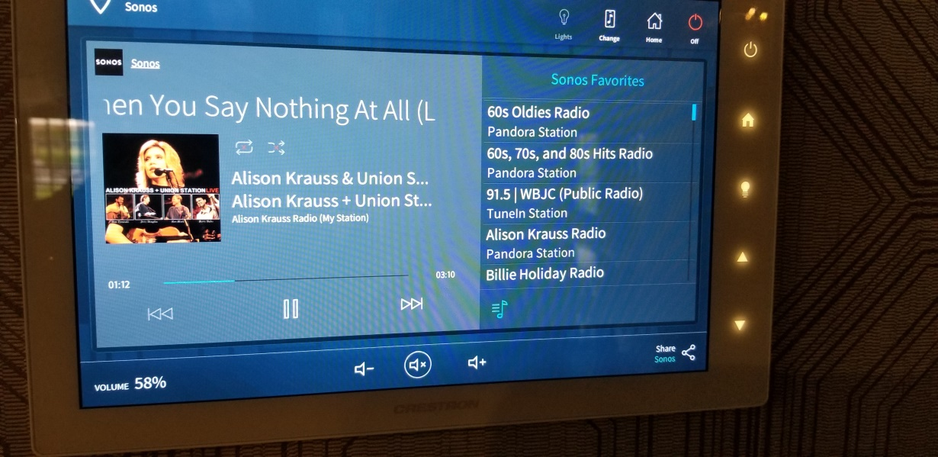
TURNING THE SYSTEM OFF  Press the OFF button in the upper right of any screen.  Select either  - Turn off the room you are controlling  - Turn off all rooms.  Audio and Video will stop, and TVs will be turned off. | 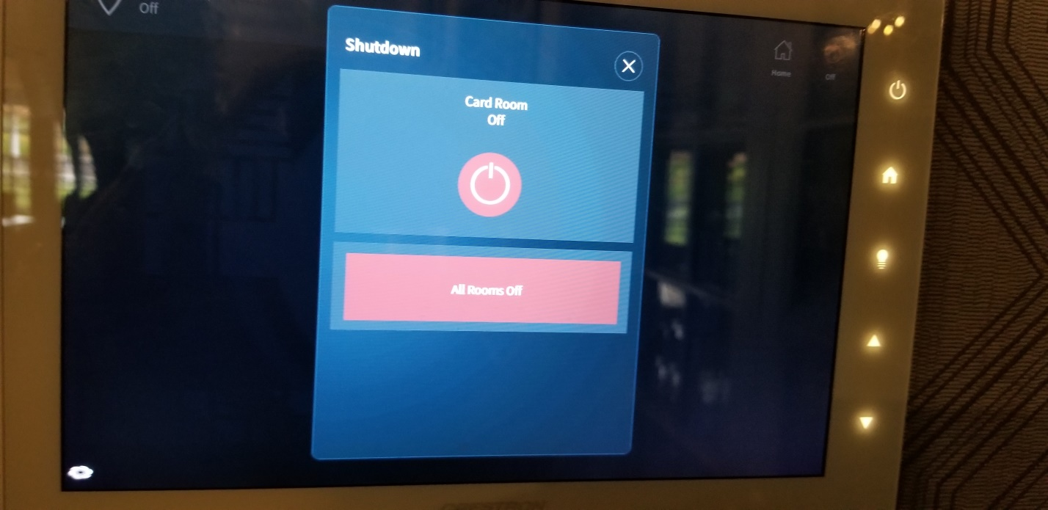

S. Leven 8/8/21

